CIS 350 – Assignment #3 – **Due Sunday** **before 11:55pm**

**Step 1:**

* Download the Prototype 2 assets by [direct download](https://connect-prd-cdn.unity.com/20191004/ad0eda1d-ed30-4da0-83b2-fdb658bf4386/Prototype%202%20-%20Direct%20Download.zip?_ga=2.27400444.1795485000.1598410231-1565378913.1590020947) or from the [Asset Store](https://assetstore.unity.com/packages/templates/tutorials/create-with-code-prototype-2-feed-the-animals-146037?_ga=2.27400444.1795485000.1598410231-1565378913.1590020947)
* Import the assets into the latest version of Unity 2018 (do not use version 2019, 2020, etc.)
* Follow along with the Prototype 2 Follow Along video to complete Prototype 2
* Note: There are additional required steps in the Prototype 2 video and lecture notes (slides) that are not on the Create with Code website.
* Be sure to include Prototype 2 with your submission of Challenge 2 (separate unity project folders is fine)

**Step 2**:

* Download the Challenge 2 assets by [direct download](https://connect-prd-cdn.unity.com/20191004/55f72a9b-8dbc-4e19-b4e3-6f34d5dd4b79/Challenge%202%20-%20Direct%20Download.zip?_ga=2.204100944.1795485000.1598410231-1565378913.1590020947) or from the [Asset Store](https://assetstore.unity.com/packages/templates/tutorials/create-with-code-challenge-2-play-fetch-146044?_ga=2.204100944.1795485000.1598410231-1565378913.1590020947)
* Import the assets into the latest version of Unity 2018 (do not use version 2019, 2020, etc.)
* If you want to, watch the video introducing Challenge 2 [here](https://learn.unity.com/tutorial/challenge-2-play-fetch-with-random-values-and-arrays/?courseId=5cf96c41edbc2a2ca6e8810f&projectId=5cdcc312edbc2a24a41671e6&tab=overview), but **there will be additional requirements listed below**

**Challenge 2 Requirements Part 1 (Requirements from Create with Code)**

* Dogs are spawning at the top of the screen - Make the balls spawn from the top of the screen
* The player is spawning green balls instead of dogs - Make the player spawn dogs
* The balls are destroyed if anywhere near the dog - The balls should only be destroyed when coming into direct contact with a dog
* Nothing is being destroyed off screen - Balls should be destroyed when they leave the bottom of the screen and dogs should be destroyed when they leave the bottom of the screen
* Only one type of ball is being spawned - Ball 1, 2, and 3 should be spawned randomly
* The spawn interval is always the same - Make the spawn interval a random value between 3 seconds and 5 seconds
* The player can “spam” the spacebar key - Only allow the player to spawn a new dog after a certain amount of time has passed

**Hints**

* **Make the balls spawn from the top of the screen** *Hint* - Click on the Spawn Manager object and look at the “Ball Prefabs” array
* **Make the player spawn dogs** *Hint* - Click on the Player object and look at the “Dog Prefab” variable
* **The balls should only be destroyed when coming into direct contact with a dog** *Hint* - Check out the box collider on the dog prefab
* **Balls should be destroyed when they leave the bottom of the screen and dogs should be destroyed when they leave the left side of the screen** *Hint* - In the DestroyOutOfBounds script, double-check the lowerLimit and leftLimit variables, the greater than vs less than signs, and which position (x,y,z) is being tested
* **Ball 1, 2, and 3 should be spawned randomly** *Hint* - In the SpawnRandomBall() method, you should declare a new random int index variable, then incorporate that variable into the Instantiate call
* **Make the spawn interval a random value between 3 seconds and 5 seconds** *Hint* - ~~Set the spawnInterval value to a new random number between 3 and 5 seconds in the SpawnRandomBall method~~ The hint from Create with Code is incorrect – InvokeRepeating() will always use the delay set when it is called once in Start(). Changing the variable passed into InvokeRepeating() after it has already been called will not change the spawn interval. Instead, use a coroutine, a while loop, and use Random.Range() to set the spawn interval to a random float between 3 and 5 seconds. Consider why we use a float and not an int.

**Challenge 2 Requirements Part 2 (Additional Requirements)**

* Add text display for score and health
* Optional stretch goal: display the health as 5 heart images instead of text
* Increment score when balls detects collision with an object tagged Dog
* Decrement health when ball is destroyed out of bounds at the bottom of the screen
* Add win condition: score >= 5
* Add loss condition: health == 0
* Add ability to restart after game over (Hint: if the player presses a button such as R, and the game is over, reload the scene.)

**Uploading to GitHub**

If you are having difficulty uploading your unity projects to GitHub, see [this video](https://www.youtube.com/watch?v=qpXxcvS-g3g) and this [blog post](https://www.studica.com/blog/how-to-setup-github-with-unity-step-by-step-instructions)

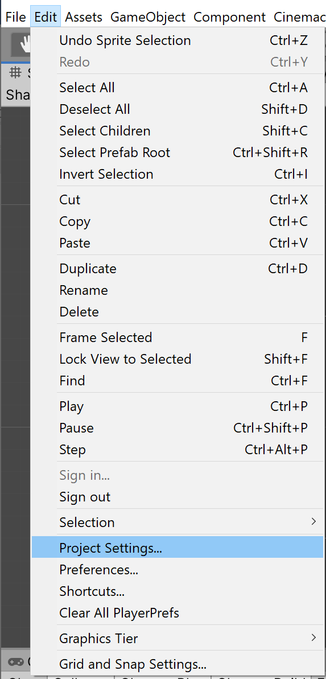 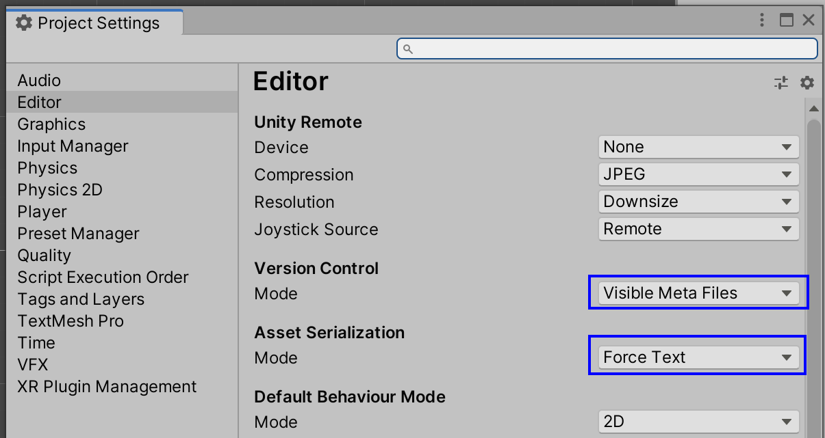

**Required Deliverable**:

* Upload the following to Canvas under Assignments: a .txt text file with a URL web address linking to a git repository containing your project folders and files for both the completed prototype and challenge. You can include two github repository links or put both unity project folders into one repository.
* You must put the .gitignore file under Resources on Canvas in your git repository before adding your project files or creating a unity project in your git repository.
* To receive credit for this assignment, all script files that you write or change **must** include the header comment below with your name on it:

/*

* (Student Name)

* (Assignment)

* (Brief description of the code in the file.

* For example: controls player movement)

*/